**DAILY ONLINE ACTIVITIES SUMMARY**

|  |  |  |  |  |  |  |  |  |
| --- | --- | --- | --- | --- | --- | --- | --- | --- |
| **Date:** | **24-05-2020** | | | | | **Name:** | **Anix Jugal D’Cunha** | |
| **Sem & Sec** | **8 sem , A sec** | | | | | **USN:** | **4al16cs013** | |
| **Online Test Summary** | | | | | | | | |
| **Subject** | | **No test was Given** | | | | | | |
| **Max. Marks** | | **----** | | **Score** | | | **----** | |
| **Certification Course Summary** | | | | | | | | |
| **Course** | The Complete 2020 PHP Full Stack Web Developer Bootcamp ( ongoing ) | | | | | | | |
| **Certificate Provider** | | | **Udemy** | | **Duration** | | | **49 hours** |
| **Coding Challenges** | | | | | | | | |
| **Problem Statement:** Not Given  ( But I have done my Internship Coding on Pyspark framework ) But its Confidential | | | | | | | | |
| **Status: Completed** | | | | | | | | |
| **Uploaded the report in Github** | | | | | **yes** | | | |
| **If yes Repository name** | | | | | **Alvas-education-foundation/dcunhaanixjugal** | | | |
| **Uploaded the report in slack** | | | | | **yes** | | | |

Online Test Details: (Attach the snapshot and briefly write the report for the same)

Not Given

Certification Course Details: (Attach the snapshot and briefly write the report for the same)

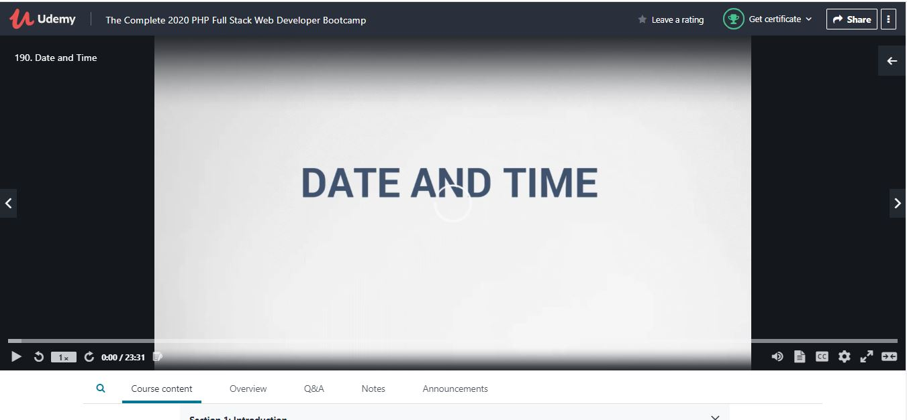

Coding Challenges Details: (Attach the snapshot and briefly write the report for the same)

Not Given ( But I have done my Internship Coding on Pyspark framework ) But its Confidential I can’t Provide it, It’s our company policy as per I have Signed in the bond